The Skunk

Up, black, striped and damasked like the chausable
At a funeral Mass, the skunk’s tail
Paraded the skunk. Night after night
I expected her like a visitor.

The refrigerator whinnied into silence.
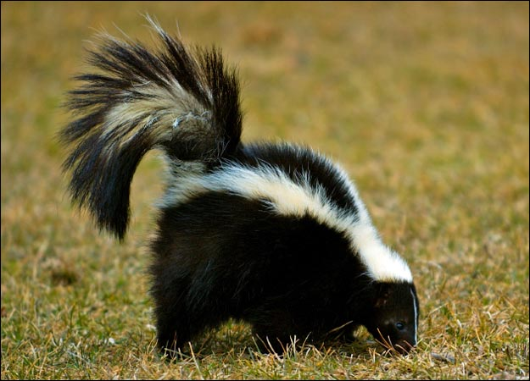
My desk light softened beyond the verandah.
Small oranges loomed in the orange tree.
I began to be tense as a voyeur.

After eleven years I was composing
Love-letters again, broaching the word ‘wife’
Like a stored cask, as if its slender vowel
Had mutated into the night earth and air

Of California. The beautiful, useless
Tang of eucalyptus spelt your absence.
The aftermath of a mouthful of wine
Was like inhaling you off a cold pillow.

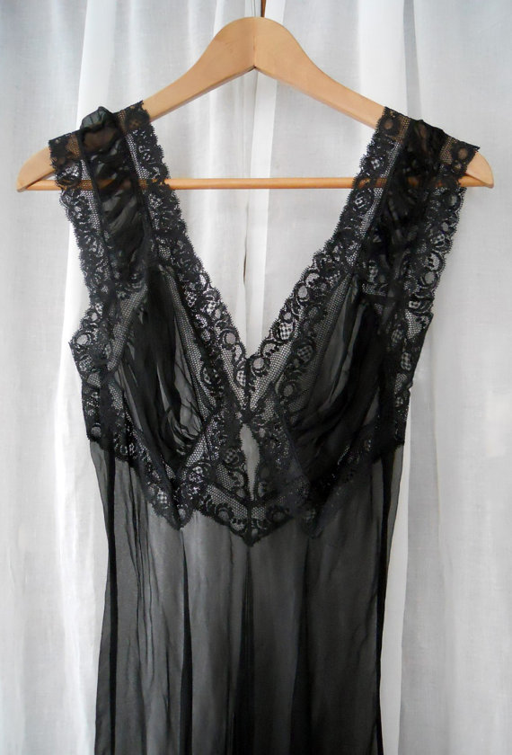
And there she was, the intent and glamorous,
Ordinary, mysterious skunk,
Mythologized, demythologized,
Snuffing the boards five feet beyond me.

It all came back to me last night, stirred
By the sootfall of your things at bedtime,
Your head-down, tail-up hunt in a bottom drawer
For the black plunge-line nightdress.

Questions:

1. How has Heaney’s separation from his wife affected his feelings for her?
2. Why do you think that Heaney is reminded of the skunk when he sees his wife bending down to find her nightdress?
3. How do you think Heaney’s wife might feel about the comparison?
4. Would you agree that this is a poem about love and memory?
5. Comment on Heaney’s use of contradictory language in this poem and its effect on the reader.
6. Compare and contrast the view of married love in this poem and ‘The Underground’.
7. How does Heaney create a sense of place in this poem?

Summary and analysis:

The poem opens with Heaney in California. He is missing his wife and, for the first time in eleven years, he is writing her love letters. Naturally, he would not have to do so if he were living at home. It seems strange to him to write the word ‘wife’ and he compares the word to a cask of wine that has been stored away but is now about to be opened and savoured. This is an image of their marriage: something self-contained and precious. Heaney focuses on the word ‘wife’ itself – its strangeness highlighted by the inverted commas around it – and reflects on the sound of it, almost as if he had never really heard it before.

California, of course, was at that time associated with a freedom of expression that would not have been the norm in Ireland. Heaney said many times that his time there opened up new poetic avenues for him and imbued him with a sense of freedom he would have been unlikely to achieve in Ireland in the early seventies.

The beautiful smell of the eucalyptus tree reminds him of his wife, as does the aftertaste of wine. The euphony in ‘beautiful, useless / Tang of eucalyptus’ reflects both the loveliness of the tree’s scent and the poet’s wife’s loveliness. He remembers inhaling his wife’s scent ‘off a cold pillow’: the word ‘cold’ evoking a sense of loss and emptiness.

As Heaney sits at his desk each night, looking out the window, he is aware of the silence of the house. The intermittent noises the fridge makes seem unusually loud, like the whinny of a horse. Note Heaney’s use of the word ‘refrigerator’ rather than ‘fridge’. This American usage emphasises how far from home Heaney is. He is in a place where even the ordinary appears strange and exotic to him.

The only light is that on his desk, and it illuminates the verandah and orange trees outside. The language in the poem is intensely sensual, as befits the theme. The visual imagery is particularly striking. The harsh glow of the lamp light is softer by the time it reaches the verandah, and the oranges take on a dramatic aspect, looming in the trees. This sense of drama is heightened by the arrival of the skunk, parading around in all its glamorous mystery.

The skunk appears each evening, ‘snuffing’ around the verandah. The word ‘snuffing’ is part of the ordinariness of the skunk. Its showy tail is so much in evidence that it appears to lead the skunk: ‘the skunk’s tail / Paraded the skunk’. The tail appears ‘damasked’, which simply means shiny and patterned. It reminds Heaney of the vestment a priest would wear at a funeral mass. This reference to church links the skunk to the sacred and the mysterious.

The skunk is confident as it walks around the garden, intent on its own business and unaware of or uninterested in the poet. To an Irishman like Heaney, the skunk is quite an exotic and ‘glamorous’ creature, although it would be a common sight in California. The contradictory or paradoxical language here again shows how, to Heaney, the commonplace has taken on special meaning for the poet. It also epitomises a lasting marriage in that it must be both ordinary and mysterious if it is to survive. On a practical level, people become familiar with one another and go about their everyday lives together, but they must also retain a sense of the mythology an mystery that are a part of romantic and sexual love.

The nightly ritual of the skunk’s appearance leads to the poet becoming tense and excited as he wonders if she will appear his night. He says that the thrill he gets from watching the skunk is almost like the thrill a voyeur would experience as he secretly watched a woman. This tension and excitement, along with his admiration of the skunk’s beauty and confidence makes Heaney long for his wife. This feeling is exacerbated by his loneliness and sexual frustration.

The last stanza returns us to Heaney’s present. He is back home, some years after his stay in California. He and his wife are getting ready for bed and he hears the sensual, gentle ‘sootfall’ of her clothes as she undresses. The word ‘sootfall’ is a most evocative one. As her clothes hit the floor they make a soft sound similar to soot falling down a chimney. He is ‘stirred’ by this, and as she bends down to get her nightdress from the bottom drawer, he is reminded of the skunk ‘snuffing’ around the verandah. The sexual tension he felt then is linked to his arousal now.

It is worth taking a moment to look closely at the word ‘sootfall’. Like the skunk itself, it seems a strange image to connect to a loved one and to sexual desire. Soot, after all, is dirty. Yet Heaney is aroused or ‘stirred’ by the sound. However, one critic said that if we think about it practically, clothes taken off at the end of the day and let fall to the floor are dirty too, and Heaney’s reaction is part of the ‘ordinary mysteriousness’ of marriage. You may disagree, and may think that Heaney compared the clothes to soot in order to continue the link to the colour black. (The skunk, the chasuble, soot, the nightdress...)

The poem ends on a happy note. From the ‘cold pillow’ of his time alone in California and the funereal image of the priest’s chasuble, we move to the shared marriage bed at home in Ireland. The black chasuble is replaced by the black, ‘plunge-line’ nightdress. The poet longed for his wife at the beginning of the poem, and he longs for her now. This time, the longing is more like anticipation, though, as she is about to join him in bed.

Themes:
Love and marriage
This poem shows how a couple can retain their love and desire for one another even after eleven years of marriage. Heaney misses his wife deeply during his time in California, and is reminded of her by sensual pleasures such as the scent of eucalyptus or the taste of wine.

The separation forces Heaney to look at his relationship anew and he is once again like a besotted suitor, charming the object of his affections with carefully written love letters.

The poem is also a celebration of the erotic love that exists in marriage. At the end of the poem, Heaney is still ‘stirred’ by the mere sound of his wife’s clothes falling to the floor, even though they have now been together for many years.

Memory
The poem shows just how intense and powerful memory can be. At the start of the poem Heaney remembers his wife when he tastes wine, smells eucalyptus and even when he finds himself anticipating the nightly visit of the skunk. Back in Ireland, his wife reminds him of the skunk by her ‘tail-up’ search for her nightdress in a bottom drawer, and this in turn reminds him of how much he missed her and longed for her during his stay in America.

Seamus Heaney – an appreciation
In Seamus Heaney's poetry, ordinary objects and places – a sofa, a satchel, the sound of rain – are sanctified. But it has edge and politics, too. Blake Morrison recognises an astonishing poetic achievement.

  - Blake Morrison
  - The Guardian, Friday 6 September 2013 14.00 BST

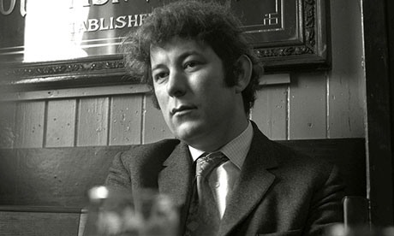
Seamus Heaney in 1970. Photograph: REX/ITV
People kept calling him the greatest Irish poet since WB Yeats. Now he has gone, perhaps it is time to put it another way, and say that Yeats was the greatest Irish poet till Heaney. Seamus would have demurred;poetry's not a contest. But they do belong to the same stratosphere. And in a week when the favourite adjective used about Heaney in the media has been "earthy", it's something that needs to be said. "Earthy" may be no more than shorthand for "farmer's son" or for distinguishing him from the more cerebral Joyce and Beckett. But if it suggests unsophisticated, hearty or coarse, it's wildly misleading. Steadfast, certainly. Grounded, some of the time. But earthy, no, the word's not right.
Whatever he owed to Yeats, Heaney more than gave back. For instance, Yeats had dreamed of writing a poem "maybe as cold/ And passionate as the dawn" about an imaginary fisherman ("The freckled man who goes/ To a gray place on a hill/ In gray Connemara clothes"). Heaney got on and wrote that poem, about a real fisherman, Louis O'Neill, a regular at his father-in-law's pub in Ardboe, who was killed in a bomb attack after defying the curfew imposed in the wake of Bloody Sunday, when British troops shot dead 13 Catholics. The poem is less an elegy than the exploration of a moral conundrum: "How culpable was he/ That last night when he broke/ Our tribe's complicity?" "Casualty" ends with a memory of the two of them out fishing in a boat one morning. "I tasted freedom with him," Heaney says, and asserts the importance of being yourself, and going your own way, in poetry as in life:
To get out early, haul
Steadily off the bottom,
Dispraise the catch, and smile
As you find a rhythm
Working you, slow mile by mile,
Into your proper haunt,
Somewhere, well out, beyond.
Heaney admired writers (Ovid, Joyce, Mandelstam) who refused to compromise their artistic independence. But he also felt the counter-pull of duty – loyalty to family, tribe, home, nation, religion. You could say it was the central struggle of his life: how to find the time and space to nurture his art, when everyone wanted a piece of him – to give a reading here, go on a lecture tour there, review that book, attend this dinner, judge that prize. The pressure was on long before the award of the Nobel prize in 1995. I had a glimpse of it in Belfast, at the end of the 1970s, when he was still in his 30s. He was living in the south by then but had come up for the day to do a broadcast for Paul Muldoon (then a BBC radio producer). Afterwards, outside in the street, the three of us had barely walked 10 yards before a car screeched to a halt and a man rushed over: "Mr Heaney, Mr Heaney, can I have your autograph?" Ever obliging, Seamus signed his name. So it went on. Ireland accords its poets a special place, as we saw at Monday's funeral, but the demands on him were global. After readings, there were always hour-long queues.
The poems that made his name recall a rural childhood: poems about potato-digging, milk-churning, thatching, blackberrying, water-divining; poems strong on euphony, alliteration and other classroom-friendly devices; poems (as one reviewer put it) "loud with the slap of the spade and sour with the stink of turned earth". There was a lot more to them than this, though, including self-consciousness ("I rhyme to see myself/to set the darkness echoing") and a need to guiltily measure himself against his father and forefathers, from whose path (pen rather than spade in hand) he had deviated. He took the praise from English reviewers but felt suspicious of it. To be labelled as a poet with PQ – "peasant quality" – had more than a hint of condescension. And though his instinct was to load every rift with ore, he didn't want to be known as an Irish wordsmith. As his friend Seamus Deane put it, "a reputation for linguistic extravagance is dangerous, especially when given to small nations by a bigger one … By means of it Celts can stay quaint and stay put."
By the time the political climate of Northern Ireland changed at the end of the 1960s – with civil rights campaigns, riots, and the calling-in of British troops – Heaney's poetry was changing, too. His verse-forms became sharper, like drills. Even his poems about local place-names were edgy, as in "Broagh", with "that last gh the strangers found difficult to manage". It was a tricky path to tread, between being responsive to the moment and independent of party lines; between using poetry as a slingstone to help the desperate and respecting the "diamond absolutes" of art; between labouring over poems and allowing them to come unexpectedly, "like a ball kicked in from nowhere". But the times, or his conscience, demanded it.
Sorry for his nation's Troubles, he published North, a collection intended to explain and console. The first half covers 2,000 years of northern European history, from earth-sacrifices through Viking raids to Elizabethan colonisation; the second half offers reportage on the present – shootings, bombs, neighbourly murders. In "Punishment", these two strands come together brilliantly as he connects the hanging of a young woman for adultery (her body preserved in a Danish bog for two millennia) with the tarring and feathering by Republican hardliners of Catholic girls guilty of consorting with British soldiers. The loving attention to the female victims doesn't preclude an understanding of their persecutors. "At one minute," Heaney wrote in a piece of journalism at the time, "you are drawn towards the old vortex of racial and religious instinct, at another time you seek the mean of humane love and reason." The ending of the poem is poised between the two:
I who have stood dumb
when your betraying sisters,
cauled in tar,
wept by the railings
who would connive
in civilized outrage
yet understand the exact
and tribal, intimate revenge.
Heaney's poetry is full of accusations – often self-accusations, voiced by others: the ghost of his second cousin, Colum, a victim of sectarian murder, who tells him "[you] saccharined my death with morning dew"; the unnamed Sinn Féin hierarch (Danny Morrison, in fact) who sits down opposite him on a train to Belfast and demands: "When, for fuck's sake, are you going to write/Something for us?"; his wife, Marie, who asks "Why could you not have, oftener, in our years/Unclenched, and come down laughing from your room/And walked the twilight with me and your children?" He has answers for all of them – for Marie, the answer is two of the most surprising and beautiful love poems in the language, "The Otter" and "The Skunk". But worries about whether he is doing the right thing are integral to Heaney's poetry, and that vulnerability is part of their strength. "Incertus" was an early pseudonym he used, and even after becoming Famous Seamus a shyness and tentativeness remained. No poet was ever less pompous.
Much of his poetry was written from a cottage in Glanmore, to where he would retreat from the house in Dublin or between teaching spells in the US. At the end of North, and in his next, equally magnificent collection,Field Work, he presents himself as a wood-kerne escaped from the massacre, a man who has left the urban battlefront for Wordsworthian seclusion or Ovidian exile. It was a necessary strategy: a way to clear some space for himself. But as Andrew Motion and I discovered, it didn't betoken quietism or the surrender of a public voice. We had given him pride of place among the 20 writers included in The Penguin Book of Contemporary British Poetry in 1982. It wasn't the first time he had featured in an anthology with the word "British" in the title. But he decided it would be the last. People were killing and being killed over the issue of Britishness and Irishness, and his identity was on the line. "Be advised/My passport's green," he told us in "An Open Letter". "No glass of ours was ever raised/ To toast The Queen." The rebuff couldn't have been more gracious but thereafter he was Irish, no messing.
I had got to know Heaney after publishing a book about him that same year – only a short book, soon superseded by others, but he was grateful for the advocacy (and for the fact I hadn't pestered him while writing it), and declined to play lordly creator to his grubbing scholar. He was quick with jokes, puns and anecdotes, and liked a good gossip, but there was no malice. With his warmth and (later) that shock of white hair, he lit up a room. Audiences were spellbound when he read. He had a gift for being himself, or for seeming to be. The easy onstage charm was deceptive: to combat nerves, and choose the right poems for the occasion, he sometimes spent two or three hours preparing.
Like Yeats, he had a talent for reinventing himself. "Time to be dazzled and the heart to lighten," he announced in the 1990s, with Seeing Things, berating his past poetry for being heavy, sluggish, in the doldrums, and of having to wait "until I was nearly fifty/to credit marvels". He was being too hard on himself, as always. The luminous and the numinous had long been a feature of his work: "here is love/like a tinsmith's scoop/sunk past its gleam/in the meal-bin" – nothing sluggish about that. But it is true he lightened up. "For years I was bowed over the desk like some monk bowed over his prie-dieu," he said in his Nobel lecture. Now was time for the marvellous as well as the murderous – to walk on air against one's better judgment. Trust, agility, give-and-take, "a less binary and altogether less binding vocabulary": the qualities he espoused, as a poet, would also, he thought, help bring peace in Northern Ireland.
His later poems make room for everyday miracles and otherworldly wisdom. There is a lovely one about a ship that appears in the air while the monks of Clonmacnoise are at prayer. According to legend, the ship's anchor gets hooked on the altar rail:
A crewman shinned and grappled down the rope
And struggled to release it. But in vain.
'This man can't bear our life here and will drown,'
The abbot said, 'unless we help him.' So
They did, the freed ship sailed, and the man climbed back
Out of the marvellous as he had known it.
For Heaney, there were marvels enough in this world, and never mind the next. Ordinary objects and places – a sofa, a wireless, a satchel, a gust of wind, the sound of rain – were sanctified. His Catholicism ran deep: in his teens he made pilgrimages to Lough Derg and Lourdes, and he thought of writing as a sacred act: "When I sit opposite the desk, it's like being an altar boy in the sacristy getting ready to go out on to the main altar." Religion taught him reverence but the gods of the hearth were what he revered – the den-life he had known as a child. He kept coming back to it and finding new things, or seeing the same things in a new light. In "Digging", his pen rests "snug as a gun". In a late poem, "The Conway Stewart", the pen is named and given a "snottery" life of its own, "The nib uncapped,/Treating it to its first deep snorkel/In a newly opened ink-bottle."
Has any poet since Wordsworth written so lovingly of his childhood – its textures, sounds and furniture, and all the relations (parents, siblings, aunts, neighbours and cousins) who populated its domain? There was no need for Heaney to publish a memoir, because the poems do the remembering (and the remembrances) with a resonance no prose could equal. Still, he did collude in a biography of sorts, a 500-page book of interviews with Dennis O'Driscoll (another poet who died recently and all too young), which looks back on the life, and the work, in illuminating detail. The poems must always come first, then Beowulf, then the essays. But Stepping Stones shouldn't be missed.
Seamus himself will be missed, hugely: for his critical intelligence, his old-fashioned courtesy and his deep learning (no one who read his 2010 collection Human Chain would have been surprised that his last words were texted in Latin). Above all, though, because he showed what poetry was capable of, and how many people it could reach without ingratiation or dumbing down. To record "the music of what happens" was his mission. It's hard to believe that music has stopped.

